## **Daily Scrum Chats**

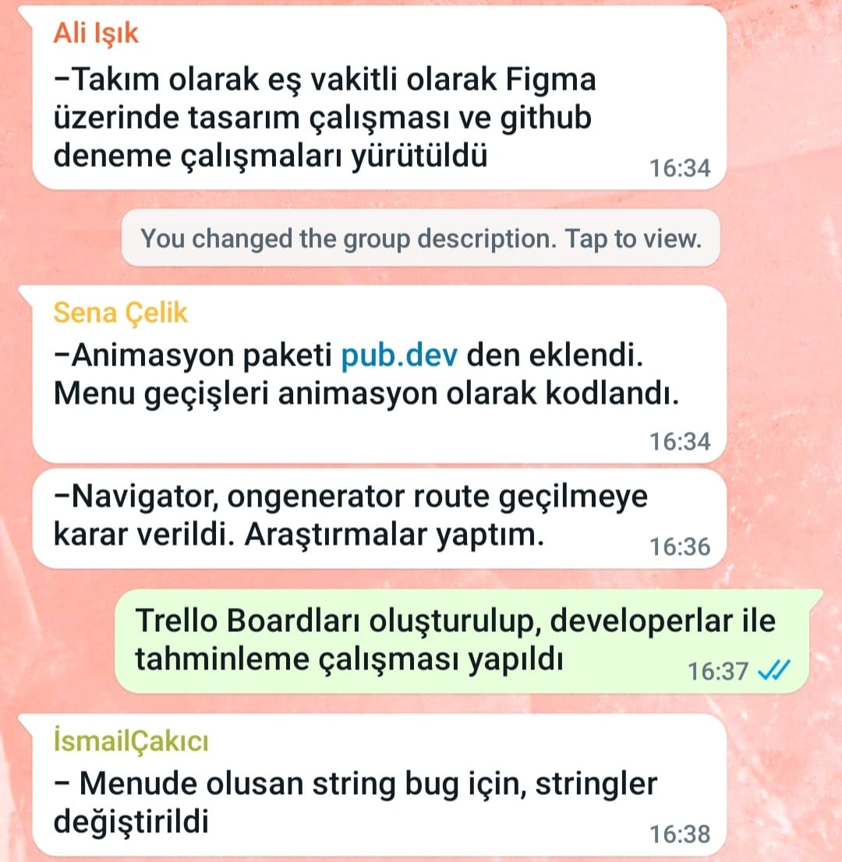

**Şekil 1- 09.05.2022 Daily Scrum_Sprint_2**

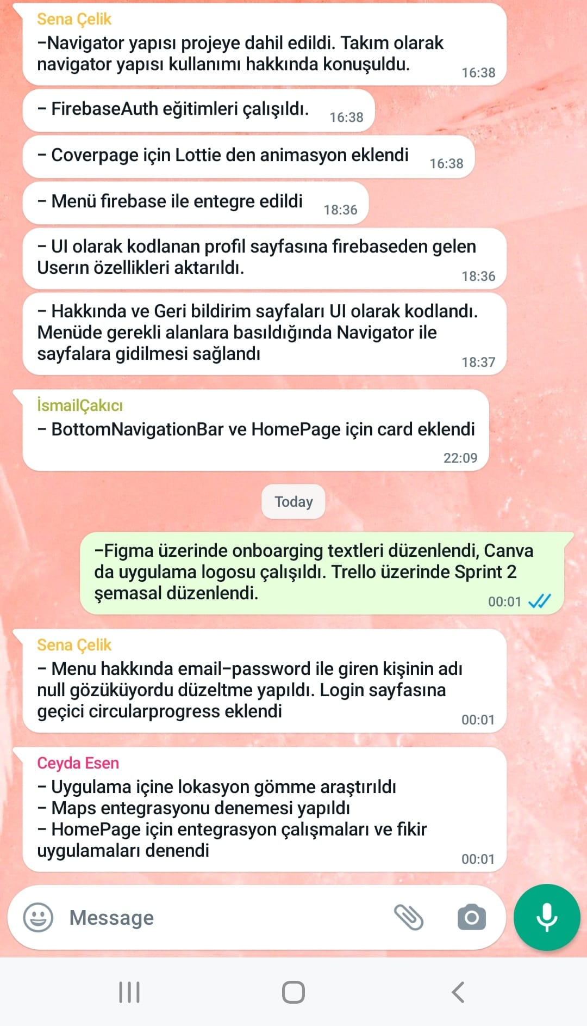

**Şekil 2 - 10.05.2022 Daily Scrum_Sprint_2**

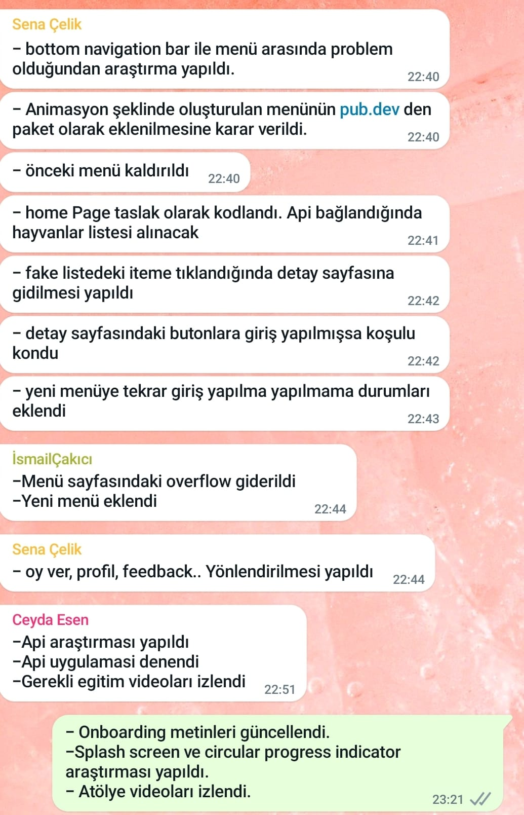

**Şekil 3- 11.05.2022 Daily Scrum_Sprint_2**

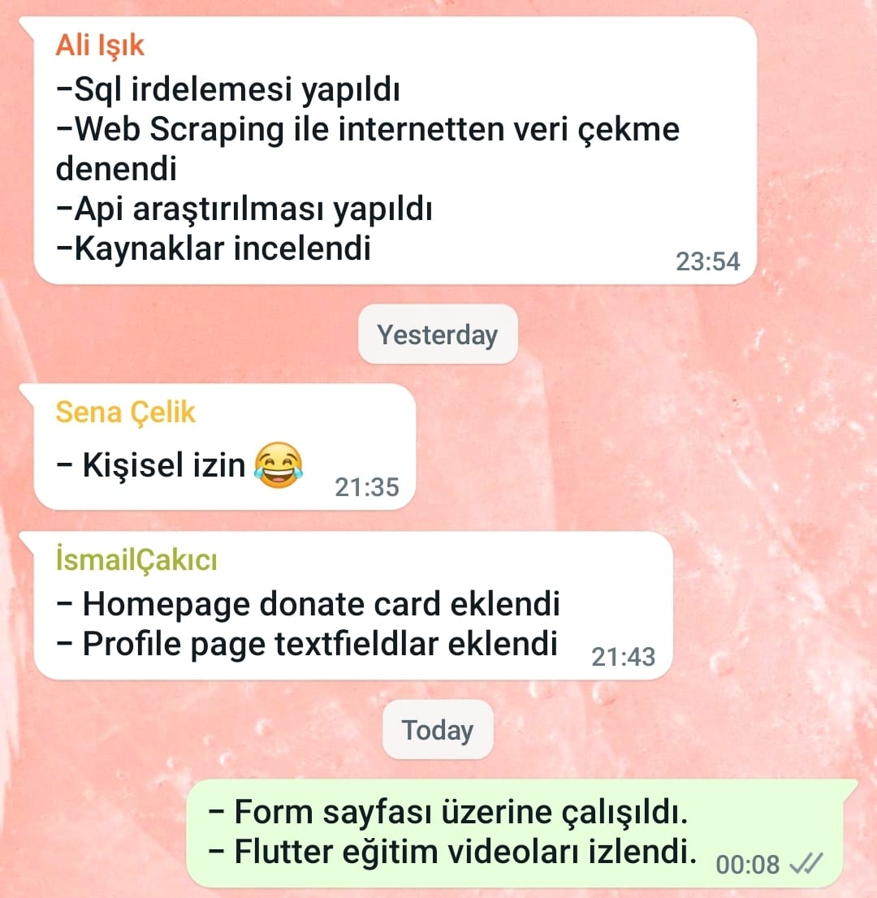

**Şekil 4- 12.05.2022 Daily Scrum_Sprint_2**

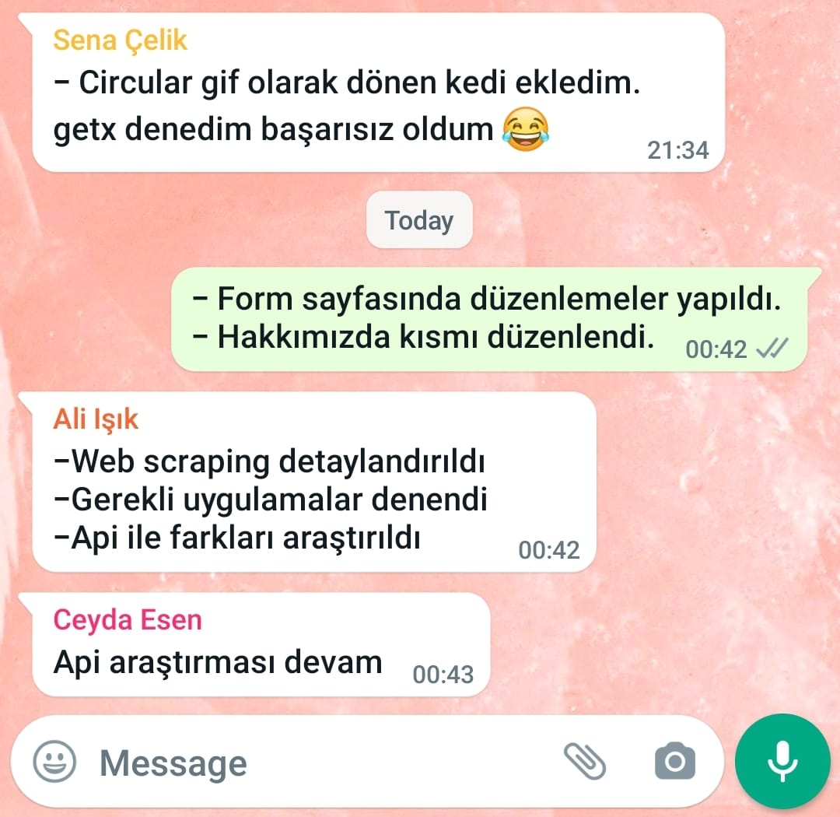

**Şekil 5- 13.05.2022 Daily Scrum_Sprint_2**

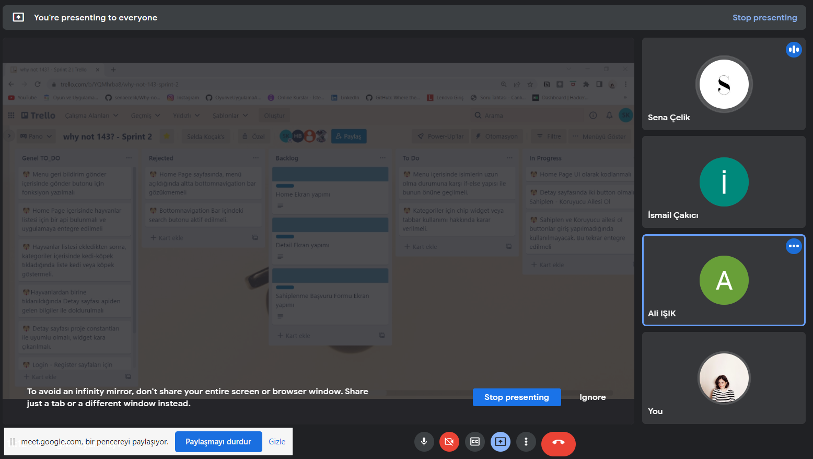

**Şekil 6- 14.05.2022_Daily Scrum_Sprint_2**

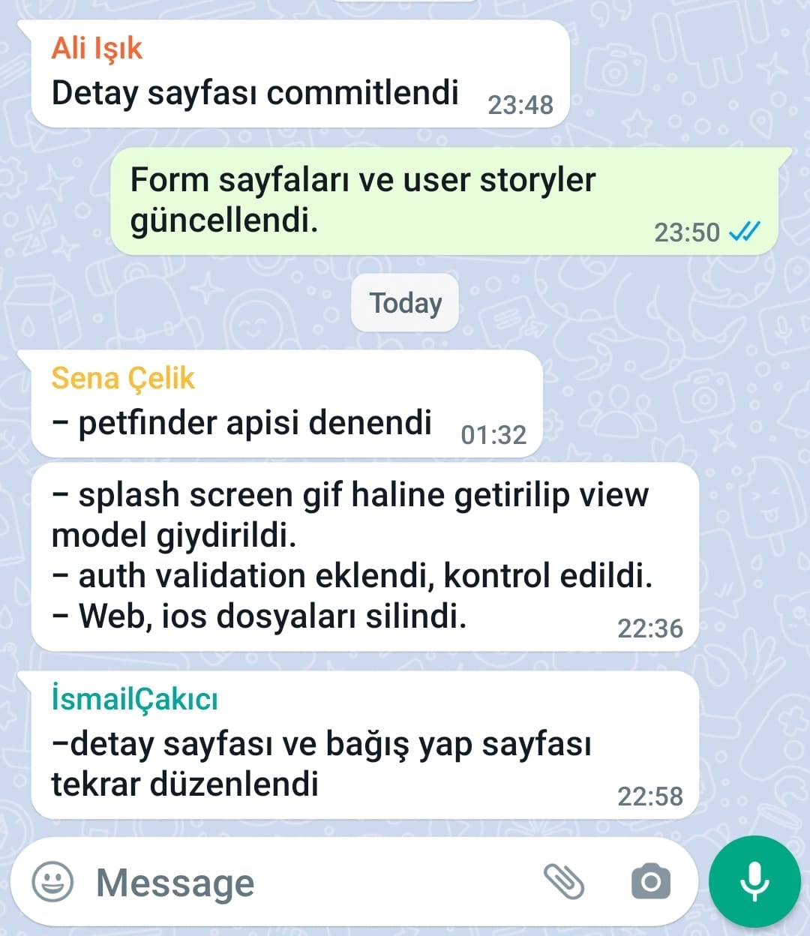

**Şekil 7 - 15.05.2022 - Daily_Scrum_Sprint_2**

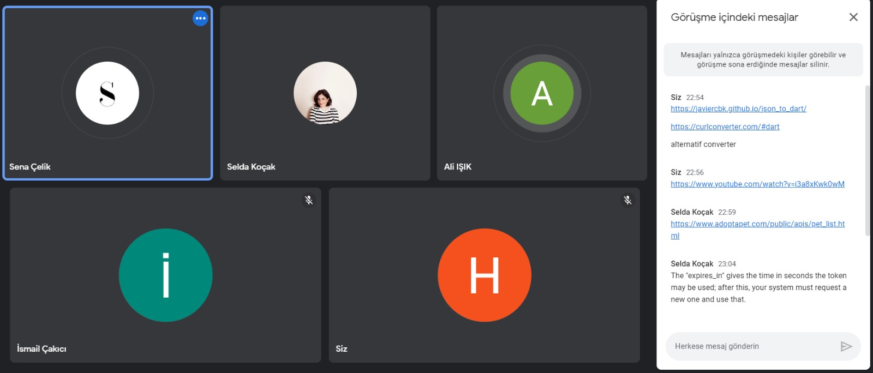

**Şekil 8 - 16.05.2022 - Daily_Scrum_Sprint_2**

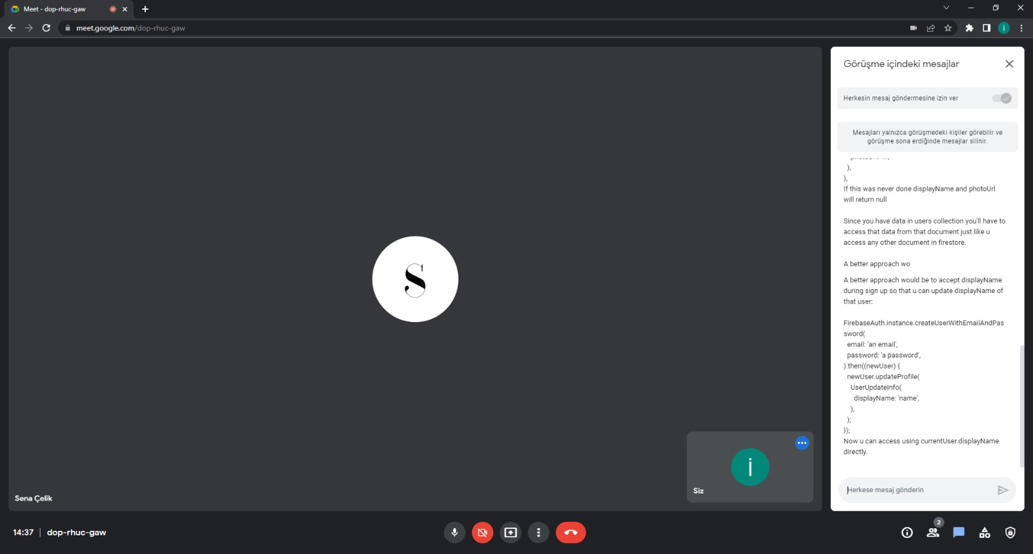

**Şekil 9- 17.05.2022_Daily_Scrum_Sprint_2**

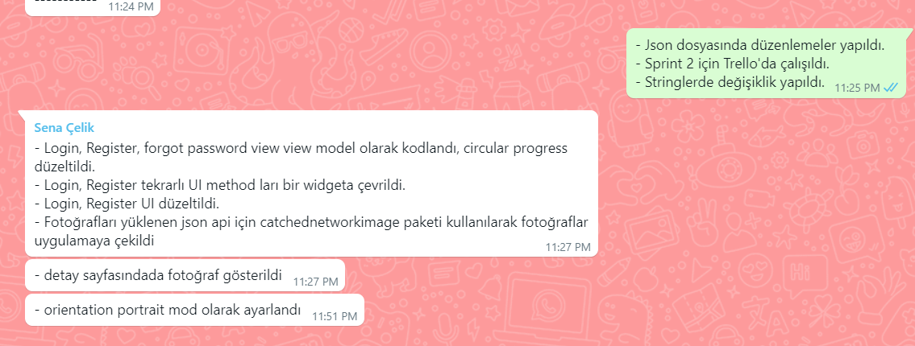

**Şekil 10 - 18.05.2022_Daily_Scrum_Sprint_2**

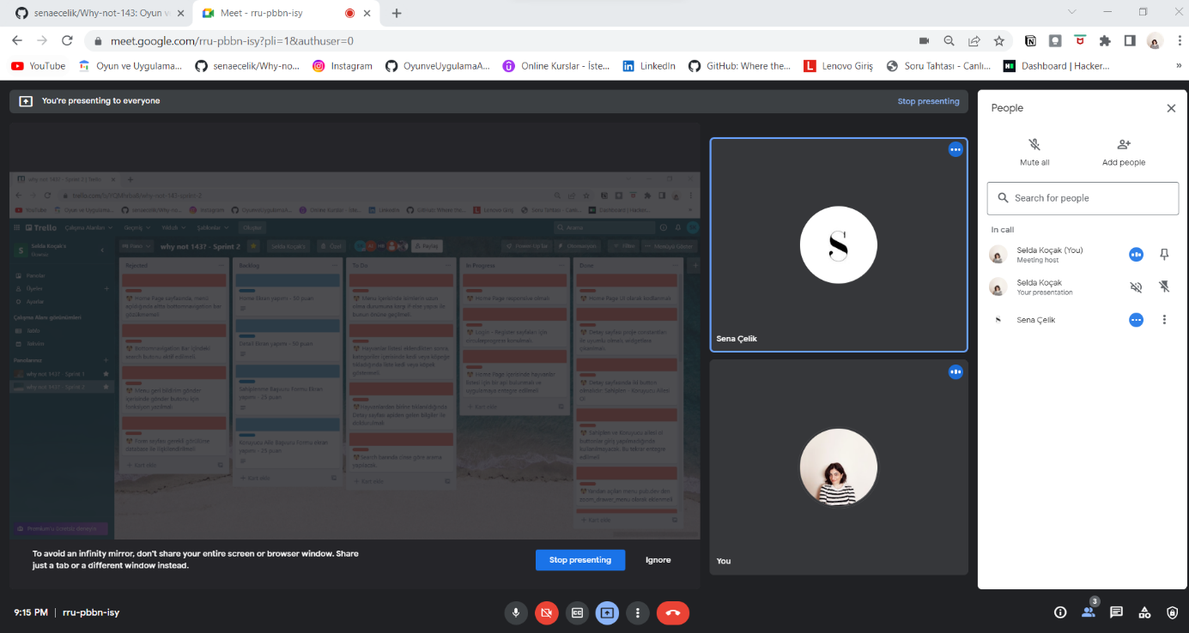

**Şekil 11 - 19.05.2022_Daily_Scrum_Sprint_2**

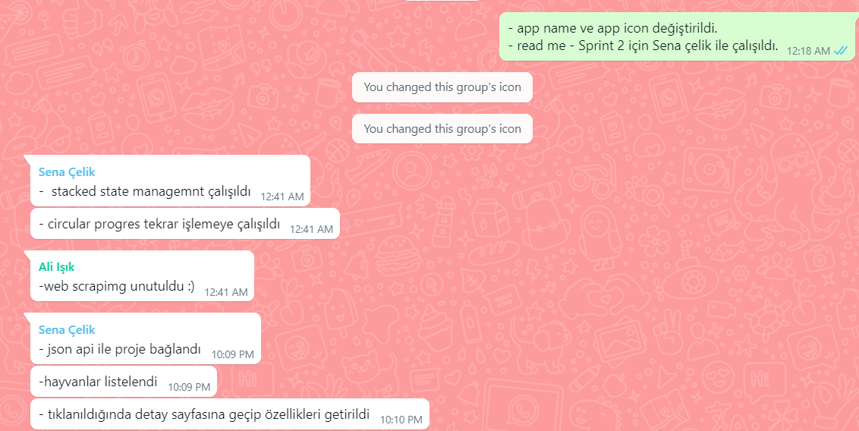

**Şekil 12 - 20.05.2022_Daily_Scrum_Sprint_2**

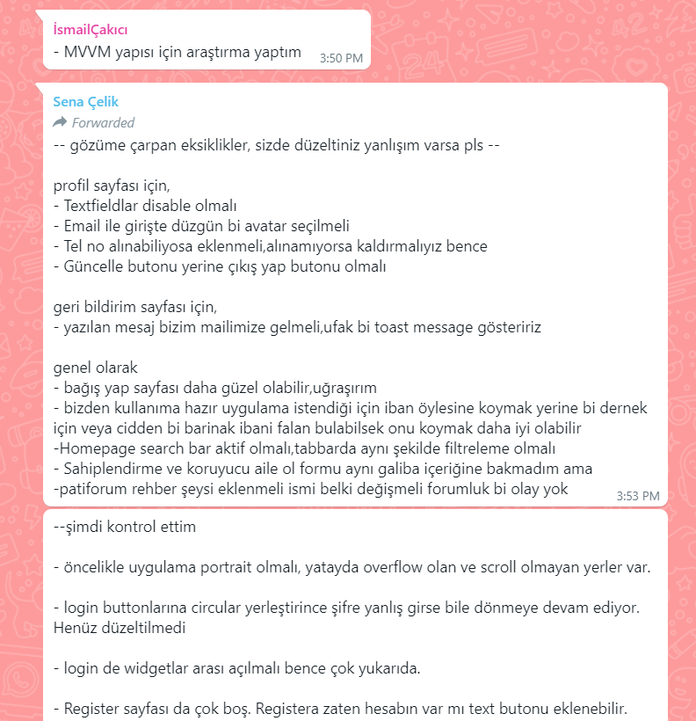

**Şekil 13 - 21.05.2022_Daily_Scrum_Sprint_2_Uygulama hakkındaki kullanıcı deneyimleri toplandı.**

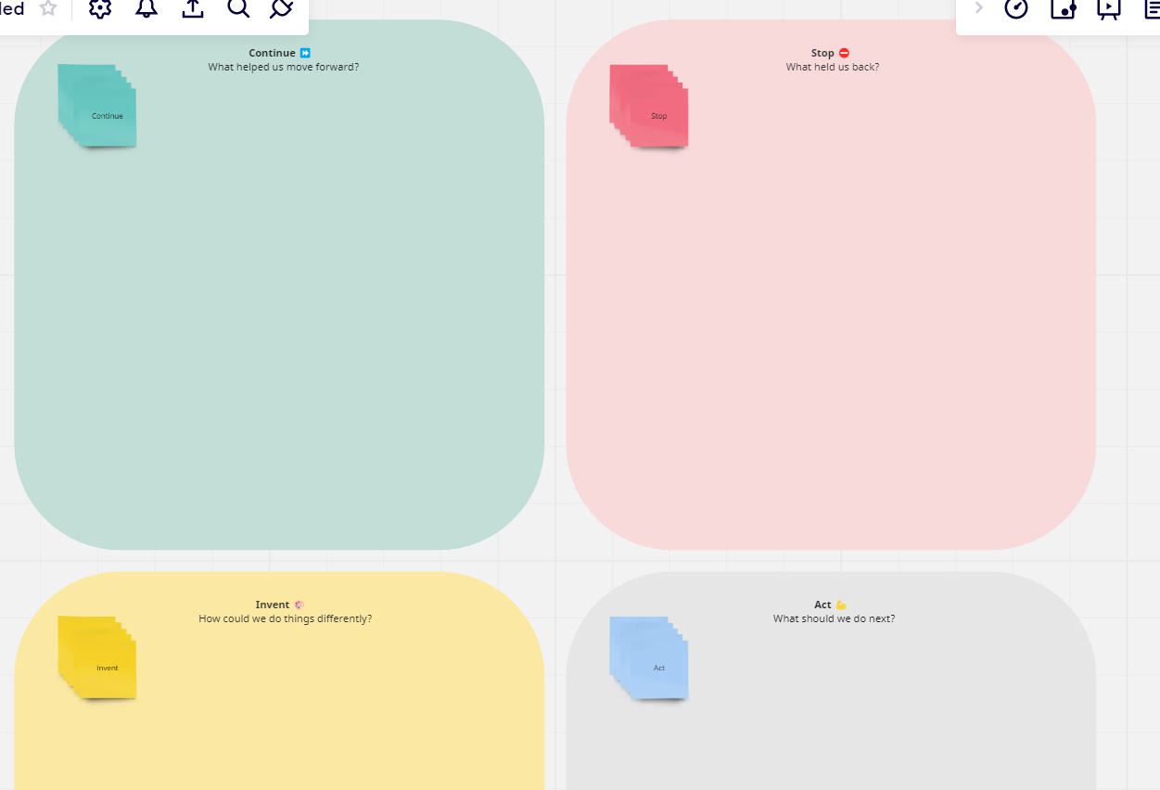

**Şekil 14- 22.05.2022_Daily_Scrum_Sprint_2_Sprint Retrospective ve Değerlendirme Şablonu**